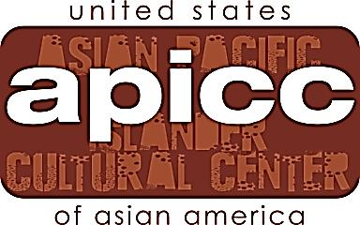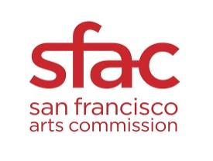

FOR IMMEDIATE RELEASE
CONTACT: Cecilia Gaerlan at ceciliagaerlan@yahoo.com; (510) 520-8540
www.facebook.com/BataanLegacy

Bataan Legacy – Rediscovering the Role of the Filipinos during World War II through Literature and Theatre

San Francisco, CA – March 1, 2013 - The San Francisco Public Library and Artis Mundi will present Bataan Legacy on Sunday, May 5, 2013, at 2PM at the Koret Auditorium at the San Francisco Public Library located at 100 Larkin Street in San Francisco, CA. The event will also be supported by the Asian Pacific Islander Cultural Center of the San Francisco Arts Commission. Doors will open at 1:30PM. Admission is free.

The Bataan Legacy Project was created to depict the real story of World War II in the Philippines and the major role of the Filipinos during the war. The multi-media program will combine theatre, film, music, photographs and spoken word to depict stories of World War II in the Philippines. The presentation will be made by Cecilia Gaerlan, playwright and author of In Her Mother’s Image, a novel and stage play set during World War II in the Philippines portraying the emotional toll of war. State Senator Leland Yee will speak about Legislation AB199 which was passed to include in Grades 7-12 curriculum the role of the Filipinos during World War II. The highlight of this multi-media program will be the appearance of several Bataan veterans who will speak about their experiences during the war. The event will be emceed by Fred Basconcillo, former President of the Ironworkers Local 790 for seventeen years and a pioneer in the labor movement.

In Her Mother’s Image has served as a springboard to rediscover the role of the Filipinos during World War II in the Philippines through Artis Mundi which uses the power of theatre to achieve social change through works based on history. It is part of the Bataan Legacy Project.

The price of peace was paid dearly by the defenders of Bataan. But their place in history has been ignored, derided, and even maligned. The men of Bataan fought a fierce and bitter battle that disrupted the timetable of the Japanese occupation, enabling the Allied Forces to harness the resources that turned the tide of war in the Pacific. And yet, five months after the war ended, the benefits for the Filipino veterans were rescinded by President Truman in 1946 and to this day have not been fully restored. The recent decision by the ninth Circuit of the U.S. Court of Appeals to reject the veterans’ claims has tipped the scales of justice even further. Only a handful of these veterans are left and soon they will pass on without receiving recognition for their great sacrifice. This is a rare opportunity to meet the few survivors of Bataan and Corregidor and to learn the true story of World War II in the Philippines. Please join us for this very important event!

