Filipino American Democratic Club of San Mateo County

P.O. Bo 4446 * Burlingame, CA 94011 846 Sextant Ct, San Mateo CA 94404

WHAT?: Political Forum, “Candidates’ Night” Meet Your Next Representative!

WHEN?: March 30, 2012 at PBRC Center, Friday evening, 6:30-8:30 *

WHERE?: 2121 Junipero Serra Blvd, Daly City, across from Duggan’s Mortuary and near Century Theatres
WHO?: Candidates for State Legislative Offices and County Board of Supervisor
RSVP felamistad@gmail.com by March 29.
Learn about our representative candidates in a Q&A, question and answer forum, in Daly City. Ask questions and learn about candidates’ positions and perspectives. This primary in June may determine our next leaders, our next leaders in Sacramento and Redwood City. The FilAm Democratic Club of San Mateo County has been part of the community’s political and social network for many years. Learn more about the political issues. Learn more about the political dynamics of San Mateo County. Your vote counts, so count on the Club to educate and empower our citizens!
Fel Anthony Amistad is the president of the FilAmerican Democratic Club of San Mateo County, and can be reached at 650-544-5221. The Club and its members may endorse any or no candidate(s) and does not speak or represent other Clubs and party organizations. 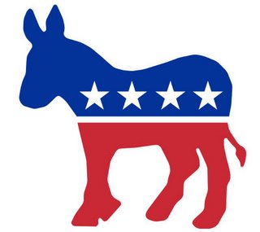
Light Refreshments will be provided *

